Books R Us CRM Requirements Specification

Final

05-02-2018

Table of Contents

1. Executive Summary 3

1.1 Project Overview 3

1.2 Purpose and Scope of this Specification 3

2. Product/Service Description 3

2.1 Product Context 3

2.2 User Characteristics 3

2.3 Assumptions 3

2.4 Constraints 3

2.5 Dependencies 4

3. Requirements 4

3.1 Functional Requirements 5

3.2 User Interface Requirements 5

3.3 Usability 5

3.4 Performance 6

3.4.1 Capacity 6

3.4.2 Availability 6

3.4.3 Latency 6

3.5 Manageability/Maintainability 6

3.5.1 Monitoring 6

3.5.2 Maintenance 6

3.5.3 Operations 6

3.6 System Interface/Integration 7

3.6.1 Network and Hardware Interfaces 7

3.6.2 Systems Interfaces 7

3.7 Security 8

3.7.1 Protection 8

3.7.2 Authorization and Authentication 8

3.8 Data Management 8

3.9 Standards Compliance 8

3.10 Portability 8

4. User Scenarios/Use Cases 9

5. Deleted or Deferred Requirements 9

6. Requirements Confirmation/Stakeholder sign-off 10

APPENDIX 11

Appendix A. Definitions, Acronyms, and Abbreviations 11

Appendix B. References 11

Appendix C. Requirements Traceability Matrix 11

Appendix D. Organizing the Requirements 13

# Executive Summary

## Project Overview

Project Name: Books R Us CRM Database

Project Manager: Ariel Gelman (ariel.gelman@stu.laroche.edu)

Assistant Project Manager: Michael Dragun (mikedragun@gmail.com)

Customer: Books R Us

Project Sponsor: Books R Us Project Management

Project Start / End dates to: 02/12/2018 – 05/02/2018

**Project Overview:**

DataScience Incorporated will implement a Customer Relationship Management database system that will allow customer data to be centralized and accessible to Books R Us. The purpose of this system is to eliminate distributed methods of collecting data with current technology to help Books R Us make better data driven decisions using improved reporting.

## Purpose and Scope of this Specification

In scope

* CRM Database System
* CRM Entity-Relationship Diagram
* CRM Database Schema
* CRM Application Design
* CRM Database Reports
* CRM System Documentation
* Change Management Documentation
* Security Issue Documentation for CRM Database
* Manual Entry of Data into CRM Database

Out of Scope

* CRM System Training
* CRM System Maintenance or Upgrades
* CRM API to Database Implementation
* CRM API Phsyical Design
* Continued updates after project closure to CRM System Documentation
* Continued updates after project closure to CRM security issues
* Importing Data from Storage and File Systems.

# Product/Service Description

The Books R Us CRM system will centralize aggregate data for reporting about its customers from several distributed storage systems for better marketing and analysis. The CRM system will feature a SQL server database through Microsoft Azure cloud hosting services that can later be interfaced with a CRM front end Application Program Interface. Factors that generally affect this product are processes for migration, communication, technology adoption, CRM practices, and interfacing of a variety of customer backend distributed data storage channels. Customer interactions and sales order analysis along with this CRM will assist in driving up sales revenue.

## Product Context

The Books R Us CRM system like other CRM systems tracks customer data, organizes customer data, and stores all this data for management. The CRM system dashboard brings everything together by showing the latest trends and reports of customer sales data, leads, and opportunities. The Books R Us CRM system is dependent on interrelated systems to function and gather data. The major components that comprise the CRM include it’s Leads, Contacts, Opportunities, and Sales entities. The CRM interfaces with and depends upon three in-store databases, and online store for sales. All sales are piped into one of the major components known as the Sales entity. The same interconnection or relationship exists with the Leads component where the PhoneSystem (Phone System), FBPage (Facebook Page), and BooksRusApp (Books R Us App) feed in potential contacts that can then become Opportunities. To see the innerworkings of this CRM system in a more concise manner refer to the diagram on the following page.

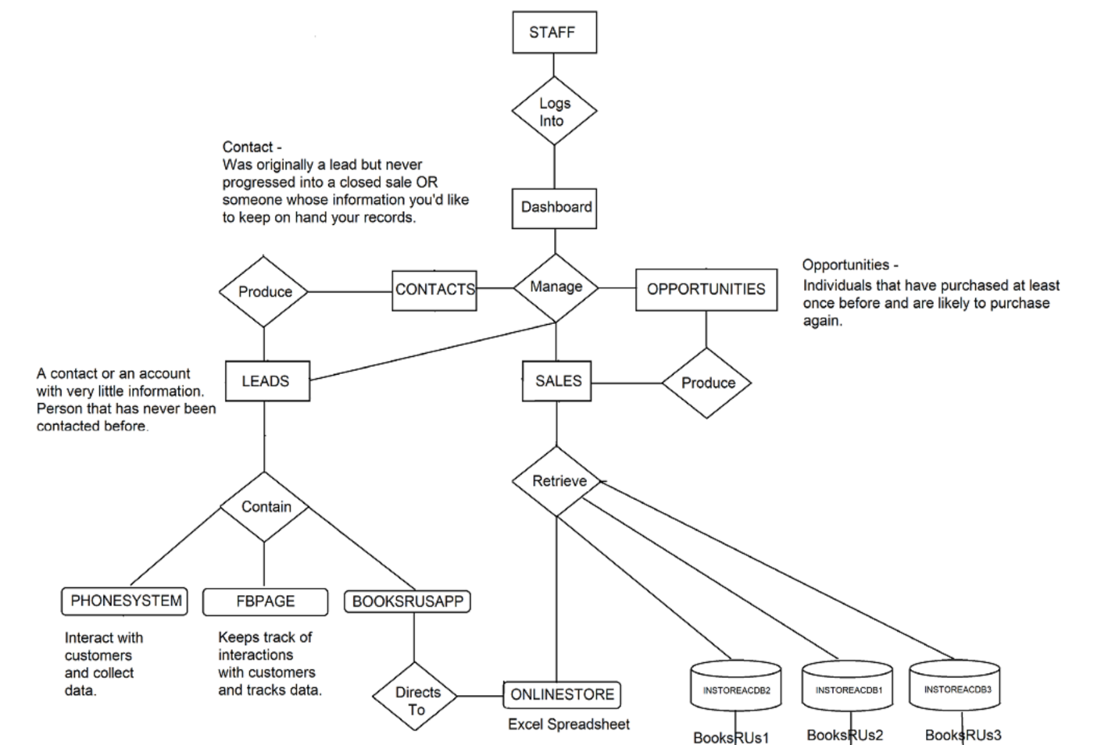

## User Characteristics

**Staff Member / CRM Analyst:**

* Experience: Customer relationship management, data analysis, business analysis, business marketing, customer service, problem resolution
* Technical Expertise: Microsoft Office, CRM software system, basic computer operation skills, ability to read charts, graphs,
* General characteristics that may influence the product

## Assumptions

* An interface may be indicated with a system that does not yet exist.
* In case the production of the system does not happen when expected, this document may have to change.

## Constraints

* **Time** (by when should the output be delivered during the process?)
* **Resources** (What are the requirements to do the work?)
* **Scope** (What exactly is the expectation of this project outcome?)
* **Cost** (How much money is expected to achieve this outcome?)
* **SQL** (how successful are we to make good queries?)

## Dependencies

* This subsection ought to indicate, or reference details of any significant capacity limitations which may be expected
* The number of contact members, the opportunities of customers, or even the quality of books may be basic variables in the determination of detailed requirements.
* Users could always send a feedback.

# Requirements

* This system of database for Book R Us is designed to collect and store data in different sections using Microsoft SQL, the way that, each data would be easy to locate.
* The Operating System to use this software would be all types of Windows, including Windows XP, Windows Vista, and so on.
* For online customers, a user name and password will be required, in order to keep their account secure.

## Functional Requirements

The Functional Requirements Specification describes what the system must do; how the system does it is described in the Design Specification.

* The Functional Requirements Specification documents the operations and activities that a system must be able to perform.
* The system should associate a supervisor indicator with each job class.
* Determine Eligibility and Suitability for Naturalization.

The following table is an example format for requirements. Choose whatever format works best for your project.

For Example:

| Req# | Requirement | Comments | Priority | Date Rvwd | SME Reviewed / Approved |
| --- | --- | --- | --- | --- | --- |
| BR_LR_05 | The system should associate a supervisor indicator with each job class. | Business Process = “Maintenance | 3 | 7/13/04 | Bob Dylan, Mick Jagger |
| BR_LR_08 | The system should handle any number of fees (existing and new) associated with unions. | Business Process = “Changing Dues in the System”  An example of a new fee is an initiation fee. | 2 | 7/13/04 | Bob Dylan, Mick Jagger |
| BR_LR_10 | The system should capture and maintain job class status (i.e., active or inactive) | Business Process = “Maintenance”  Some job classes are old and are no longer used. However, they still need to be maintained for legal, contract and historical purposes. | 2 | 7/13/04 | Bob Dylan, Mick Jagger |
| BR_LR_16 | The system should assign the Supervisor Code based on the value in the Job Class table and additional criteria as specified by the clients. | April 2005 – New requirement. It is one of three new requirements from BR_LR_03. | 2 |  |  |
| BR_LR_18 | The system should provide the Labor Relations office with the ability to override the system-derived Bargaining Unit code and the Union Code for to-be-determined employee types, including hourly appointments. | April 2005 – New requirement. It is one of three new requirements from BR_LR_04.  5/11/2005 – Priority changed from 2 to 3. | ~~2~~  3 |  |  |

## User Interface Requirements

* Many users may interact with the system during its operations and support. For instance, customers, administrators, and maintenance staff. Certain characteristics of these users, such as educational level, language, experience and technical expertise imperative limitations on the software.
* The system may be as often as possible utilized, but a few users may use it only as occasionally. Frequent users will mostly become experts, while infrequent users may still relative amateurs. It is critical to classify the customers and appraise the likely numbers in each category. In case that supreme numbers cannot expressed, relative numbers can still be valuable/
* Environmental characteristics may also require to described. It ought to not be accepted that customers are always in quite private workplaces. For instance, the required system may include terminals on benefit counters in public places. Call centers, or other type of user interface which possibly have a significant impact on requirements.

## Usability

* The system should be easy to use by users, including customers and staff, and should be well organized in a way that user errors are minimized.
* The staff members should be able to utilize all the system functions after six hours of operations. After these operations, the average number of errors made by experienced customers should not exceed three per hour.

## Performance

* This system of database is developed to perform the availability of books in different stores, including online purposes, and will interact with all members and customers. Therefore, our expectation of this database is to perform the function of all requirements that deal with Books R Us.
* The system ought to have the capacity to deal with high amount of data. In this way, it should keep large amount of books and customers without any trouble.
* The performance of the system should be fast and accurate.
* Appropriate monitoring administrator, which will update the account status, depending the number of attempts by customers.

### Capacity

* The number of online customers including Facebook, and phone system would have a large availability of user load, with the fact that most users would not have a chance to do their purchases in the store.

### Availability

* Online purchases will be available at any time
* The books RUs1, RUs2, RUs3 will be available to operate in store from 9Am till 10Pm
* The store will be closed during important holidays, but customers can still buy online.

### Latency

* Ensure that the application or components does not take too long to complete user’s tasks or use case path.
* Temporal aspects of inputs and outputs (i.e., event streams). Periodic event stream in which the time intervals.

## Manageability/Maintainability

* The system administrator will keep running anytime users need it, providing efficient tools to facilitate user’s need
* Online purchases will be available at any time.
* Users that will buy the books in the store will be able to do their operations from 9Am till 10Pm. Monday through Sunday.

### 3.5.1 Monitoring

* Contains an administration console for setting up administrative workflow, monitoring, notification, and knowledge base.
* Contains a management console for management of alerts, events, issue assignment, tracking, resolution, and to view an internal knowledge base.
* Collects performance analysis and capacity planning data.
* It allows maintenance to be scheduled, or other action to be taken to prevent consequential damages and avoid its consequences.

### Maintenance

* It specifies how users will request modifications or report problems.
* The extension of a system’s functionality and improvement in the service provided.
* Modifying the system to cope with the change in the software.

### Operations

* This system would be able to assist users need and support them at any time due to its available support on it.
* If the processes are not to be the same as those currently in the operation, determines what the progressions are, and how it is conceived that they will be realized. It exceptional that such things not be cleared to change.
* Practical experience makes clear what ought to be self-evident, that a modern system is likely to fail unless the organizational changes it expects or requires are effectively overseen to accomplish the wanted benefits.
* This project tends to stumble more over getting the users and their forms to alter than over the innovation.

## System Interface/Integration

* A first time online purchase will be able to sign up an account using a smart cell phone, or computer
* The operating systems will be:
* Windows
* Mac OS X

### Network and Hardware Interfaces

* Online purchases will be made when connected to internet
* The internet connection will be mobile data, or Wifi.
* The system will be compatible with desktop or laptop.

### Systems Interfaces

* Only managers will have access to customer’s files, in order to avoid manipulation of data.
* Managers will have more log in options than employees

## Security

* Users will only be able to edit their account, other than that, they will not be able to edit anything else.
* The system of the database will be safe and secured.
* Each user of the system will have personal login account.
* The system would not allow anyone to hack other user’s password.
* Administrator and staff members would have different accounts to access the database, thus, members can only access the database, while administrators can access and update the database
* The password would have a combination of eight digits, including numbers, symbols, lower cases and capital letters.

**DBMS Security Schema Details**

* **DBA Users**
* Our database schema can only be seen by database administrators who have the proper clearances and roles assigned through Microsoft Azure. The Centralized Administration will be utilized to arbitrate who will receive specific roles and or entitlements through Active Directory that will either limit or expand individuals depending upon their job functions. Directory roles assigned to individuals will consist of User, Global Administrator, and or a Limited Administrator for which at least several administrative roles can be selected (anything from Helpdesk Admin to a Privileged Role Admin). The individual with the role or job title of Centralized Database Security Administrator (belonging to the proper IT security group) will receive intensive training in database security techniques. With this role will come both the previously mentioned responsibilities and the responsibility of granting capabilities such as SELECT, INSERT, UPDATE, DELETE, or ALL through T-SQL language.
* The application front end will be careful and thoroughly inspected for possible SQL Injection attacks. Application front end developers will make sure that input will be read in as string text and that no capability therein exists to use DROP statements that could cause catastrophic damage to the backend database that could be irreparable. Tests will be performed also to ensure that any input received by front end form controls such as text fields do not allow the use of specified characters in the context of semi colons or other specialized characters related to SQL. All the proper guidelines and procedures will be followed for data field sanitization.
* Programmers who are working on the frontend application for the BooksRUs CRM will also not be able to view specific rows and or columns for which they are restricted access. This will be done through the creation of database views that are stored procedures.
* **CRM Users**
* Every individual who has direct contact with or is working in the CRM database will have the priority of making sure they become familiar of the many ways human error can cause problems with data integrity. Strict rules will be created for compliancy to make only certain data visible to the right individuals (again that goes with the programmers as well).
* CRM Users will be given a role from a listed of predefined roles that are available within their own database table called **CRM_Roles**. This will be connected to how and what they can access in the CRM database. Each CRM individual will be able to create a password which is stored within the **CRM_Password** database table. When a user authenticates with their ID it will go through and match the proper password for their account to then grant then the CRM access to their dashboard. Other credentials are recorded such as the CRM individual’s first and last name along with email address. Associated tasks also will be non-static or can change depending upon when the CRM User updates them. The schema is integral to the way authentication takes place and allows them to seamlessly perform the actions they need to in their BooksRus CRM application.

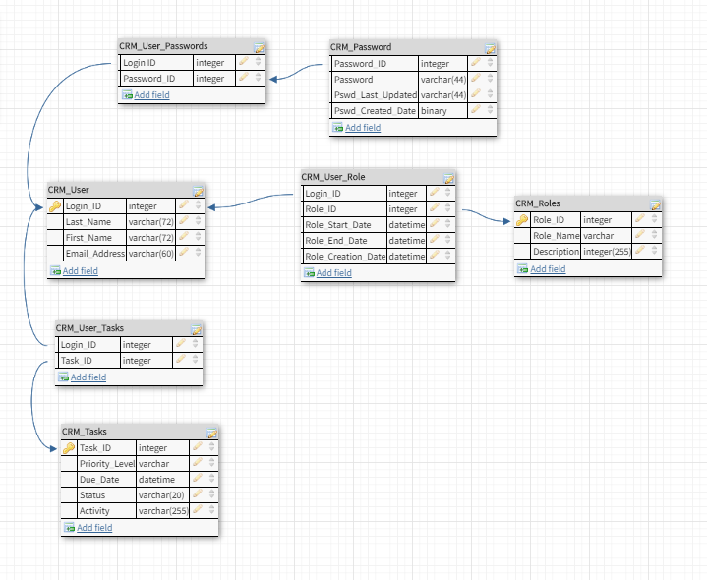

### Protection

* Alert notification
* Malware alert
* Security notification when attempt to log in 3 times
* Password: combined numbers, upper case, and lower case letters.

### Authorization and Authentication

* User name and password are required when log in

## Data Management

Specify the requirements for any information that is to be placed into a database, including

* types of information used by various functions
* frequency of use
* data access rules
* data entities and relationships
* integrity constraints
* data retention
* valid range, accuracy, and/or tolerance
* units of measure
* data formats
* default or initial values

## Standards Compliance

Specify the requirements derived from existing standards, policies, regulations, or laws (e.g., report format, data naming, accounting procedures, audit tracing). For example, this could specify the requirement for software to trace processing activity. Such traces are needed for some applications to meet minimum regulatory or financial standards. An audit trace requirement may, for example, state that all changes to a payroll database must be recorded in a trace file with before and after values.

* To ensure interoperability a standards-compliant web site does not use proprietary software methods or features of a browser.
* Must be involved to implement the policies and procedures to enact the technology to support the regulatory mandates.
* Must understand that legal requirements imposed on their data and system as dictated in regulation.

## Portability

* The Books R Us database system will be able to run any Microsoft Windows at any environment, as long as it contents Java.
* It will also have a Microsoft Access database.

# User Scenarios/Use Cases

Provide a summary of the major functions that the product will perform. Organize the functions to be understandable to the customer or a first time reader. Include use cases and business scenarios, or provide a link to a separate document (or documents). A business scenario:

* Describes a significant business need
* Identifies, documents, and ranks the problem that is driving the scenario
* Describes the business and technical environment that will resolve the problem
* States the desired objectives
* Shows the “Actors” and where they fit in the business model
* Is specific, and measurable, and uses clear metrics for success

# Deleted or Deferred Requirements

Identify any requirements that have been deleted after approval or that may be delayed until future versions of the system.

For example:

|  |  |  |  |  |  |  |
| --- | --- | --- | --- | --- | --- | --- |
| Req# | Business Requirement | Status | Comments | Pri | Date Rvwd | SME Reviewed /Approved |
| BR_LR_01 | The system should validate the relationship between Bargaining Unit/Location and Job Class. | April 2005: Deleted.  This requirement has been replaced by BR_LR_036 and BR_CC_33. | Business Process = “Assigning a Bargaining Unit to an Appointment” | 1 | 7/13/04 | Bob Dylan, Mick Jagger |
| BR_LR_02 | The system should validate that the supervisor indicator is correct according to job class.  Deferred to Phase 2B: 3/29/2005 | April 2005: Deferred to Phase 2B. | Business Process = “Assigning a Bargaining Unit to an Appointment” | 3 | 7/13/04 | Bob Dylan, Mick Jagger |
| BR_LR_03 | The system should derive the bargaining unit code, union code, and supervisor indicator from the job class code and location. | April 2005: Deleted  Replaced by BR_LR_16 and BR_LR_17. | Business Process = “Assigning a Bargaining Unit to an Appointment”; This will eliminate the need, typically, for the user to enter the bargaining unit code, union code and supervisor indicator. | 1 | 7/13/04 | Bob Dylan, Mick Jagger |

# Requirements Confirmation/Stakeholder sign-off

Include documentation of the approval or confirmation of the requirements here. For example:

|  |  |  |
| --- | --- | --- |
| Meeting Date | Attendees (name and role) | Comments |
| 7/13/07 | Bob Dylan, Labor Relations SME  Mick Jagger, Labor Relations SME  Ringo Starr, Technical Project Manager  Debbie Harry, Technical Analyst  Janis Joplin, Technical Analyst  Fred Meyer, Project Manager | Confirmed BR_LR_01 – BR_LR_15 |
| 04/15/05 | Bob Dylan, Labor Relations SME  Mick Jagger, Labor Relations SME  Ringo Starr, Technical Project Manager | Deferred / Deleted: BR_LR_01 - BR_LR_04, BR_LR_07, BR_LR_12, BR_LR_14, BR_LR_15, BR_LR_06, BR_LR_17 |

APPENDIX

The appendixes are not always considered part of the actual Requirements Specification and are not always necessary. They may include

* Sample input/output formats, descriptions of cost analysis studies, or results of user surveys;
* Supporting or background information that can help the readers of the Requirements Specification;
* A description of the problems to be solved by the system;
* Special packaging instructions for the code and the media to meet security, export, initial loading, or other requirements.

When appendixes are included, the Requirements Specification should explicitly state whether or not the appendixes are to be considered part of the requirements.

1. Definitions, Acronyms, and Abbreviations

Define all terms, acronyms, and abbreviations used in this document.

1. References – This is not a requirement for the class

List all the documents and other materials referenced in this document.

1. Requirements Traceability Matrix – This is not a requirement for the class

The following trace matrix examples show one possible use of naming standards for deliverables (FunctionalArea-DocType-NN). The number has no other meaning than to keep the documents unique. For example, the Bargaining Unit Assignment Process Flow would be BUA-PF-01.

For example (1):

| **Business Requirement** | **Area** | **Deliverables** | **Status** |
| --- | --- | --- | --- |
| BR_LR_01  The system should validate the relationship between Bargaining Unit/Location and Job Class.---Comments: Business Process = "Assigning a Bargaining Unit to an Appointment" (Priority 1) | BUA | BUA-CD-01  Assign BU Conceptual Design | Accepted |
| BUA-PF-01  Derive Bargaining Unit-Process Flow Diagram | Accepted |
| BUA-PF-01  Derive Bargaining Unit-Process Flow Diagram | Accepted |
| BR_LR_09  The system should provide the capability for the Labor Relations Office to maintain the job class/union relationship.---Comments: Business Process = "Maintenance" (Priority 1) | BUA | BUA-CD-01  Assign BU Conceptual Design | Accepted |
| BUA-PF-02  BU Assignment Rules Maint Process Flow Diagram | ReadyForReview |

For example (2):

| **BizReqID** | **Pri** | **Major Area** | **DevTstItems DelivID** | **Deliv Name** | **Status** |
| --- | --- | --- | --- | --- | --- |
| BR_LR_01 | 1 | BUA | BUA-CD-01 | Assign BU Conceptual Design | Accepted |
| BR_LR_01 | 1 | BUA | BUA-DS-02 | Bargaining Unit Assignment DB Modification Description | Accepted |
| BR_LR_01 | 1 | BUA | BUA-PF-01 | Derive Bargaining Unit-Process Flow Diagram | Accepted |
| BR_LR_01 | 1 | BUA | BUA-UCD-01 | BU Assign LR UseCase Diagram | ReadyForReview |
| BR_LR_01 | 1 | BUA | BUA-UCT-001 | BU Assignment by PC UseCase - Add Appointment and Derive UBU | Reviewed |
| BR_LR_01 | 1 | BUA | BUA-UCT-002 | BU Assignment by PC UseCase - Add Appointment (UBU Not Found) | Reviewed |
| BR_LR_01 | 1 | BUA | BUA-UCT-006 | BU Assignment by PC UseCase - Modify Appointment (Removed UBU) | Reviewed |
| BR_LR_09 | 1 | BUA | BUA-CD-01 | Assign BU Conceptual Design | Accepted |
| BR_LR_09 | 1 | BUA | BUA-DS-02 | Bargaining Unit Assignment DB Modification Description | Accepted |
| BR_LR_09 | 1 | BUA | BUA-PF-02 | BU Assignment Rules Maint Process Flow Diagram | Accepted |
| BR_LR_09 | 1 | BUA | BUA-UCD-03 | BU Assign Rules Maint UseCase Diagram | Reviewed |
| BR_LR_09 | 1 | BUA | BUA-UCT-045 | BU Assignment Rules Maint: Successfully Add New Assignment Rule | Reviewed |
| BR_LR_09 | 1 | BUA | BUA-UCT-051 | BU Assignment Rules MaintUseCase: Modify Rule | Reviewed |
| BR_LR_09 | 1 | BUA | BUA-UCT-053 | BU Assignment Rules MaintUseCase - Review Assignment Rules | Reviewed |
| BR_LR_09 | 1 | BUA | BUA-UCT-057 | BU Assignment Rules MaintUseCase: Inactivate Last Rule for a BU | Reviewed |
| BR_LR_09 | 1 | BUA | BUA-UI-02 | BU AssignRules Maint UI Mockups | ReadyForReview |
| BR_LR_09 | 1 | BUA | BUA-TC-021 | BU Assignment Rules Maint TestCase: Add New Rule (Associated Job Class Does Not Exist) - Success | ReadyForReview |
| BR_LR_09 | 1 | BUA | BUA-TC-027 | BU Assignment Rules Maint TestCase: Modify Rule - Success | ReadyForReview |
| BR_LR_09 | 1 | BUA | BUA-TC-035 | BU Assignment Rules Maint TestCase: Add New Rule (Associated Job Class Does Not Exist) - Error Condition | ReadyForReview |
| BR_LR_09 | 1 | BUA | BUA-TC-049 | BU Assignment Rules Maint TestCase: Modify Rule - Error Condition | ReadyForReview |

For example (3):

| **BizReqID** | **CD01** | **CD02** | **CD03** | **CD04** | **UI01** | **UI02** | **UCT01** | **UCT02** | **UCT03** | **TC01** | **TC02** | **TC03** | **TC04** |
| --- | --- | --- | --- | --- | --- | --- | --- | --- | --- | --- | --- | --- | --- |
| BR_LR_01 |  |  | X |  | X |  | X |  |  | X |  | X |  |
| BR_LR_09 | X |  |  | X |  | X |  |  | X |  | X |  | X |
| BR_LR_10 | X |  |  | X |  |  |  |  | X |  | X |  |  |
| BR_LR_11 |  | X |  |  |  |  |  |  |  |  |  |  |  |

1. Organizing the Requirements

This section is for information only as an aid in preparing the requirements document.

Detailed requirements tend to be extensive. Give careful consideration to your organization scheme. Some examples of organization schemes are described below:

By System Mode

Some systems behave quite differently depending on the mode of operation. For example, a control system may have different sets of functions depending on its mode: training, normal, or emergency.

By User Class

Some systems provide different sets of functions to different classes of users. For example, an elevator control system presents different capabilities to passengers, maintenance workers, and fire fighters.

By Objects

Objects are real-world entities that have a counterpart within the system. For example, in a patient monitoring system, objects include patients, sensors, nurses, rooms, physicians, medicines, etc. Associated with each object is a set of attributes (of that object) and functions (performed by that object). These functions are also called services, methods, or processes. Note that sets of objects may share attributes and services. These are grouped together as classes.

By Feature

A feature is an externally desired service by the system that may require a sequence of inputs to affect the desired result. For example, in a telephone system, features include local call, call forwarding, and conference call. Each feature is generally described in a sequence of stimulus-response pairs, and may include validity checks on inputs, exact sequencing of operations, responses to abnormal situations, including error handling and recovery, effects of parameters, relationships of inputs to outputs, including input/output sequences and formulas for input to output.

By Stimulus

Some systems can be best organized by describing their functions in terms of stimuli. For example, the functions of an automatic aircraft landing system may be organized into sections for loss of power, wind shear, sudden change in roll, vertical velocity excessive, etc.

By Response

Some systems can be best organized by describing all the functions in support of the generation of a response. For example, the functions of a personnel system may be organized into sections corresponding to all functions associated with generating paychecks, all functions associated with generating a current list of employees, etc.

By Functional Hierarchy

When none of the above organizational schemes prove helpful, the overall functionality can be organized into a hierarchy of functions organized by common inputs, common outputs, or common internal data access. Data flow diagrams and data dictionaries can be used to show the relationships between and among the functions and data.

Additional Comments

Whenever a new Requirements Specification is contemplated, more than one of the organizational techniques given above may be appropriate. In such cases, organize the specific requirements for multiple hierarchies tailored to the specific needs of the system under specification.

There are many notations, methods, and automated support tools available to aid in the documentation of requirements. For the most part, their usefulness is a function of organization. For example, when organizing by mode, finite state machines or state charts may prove helpful; when organizing by object, object-oriented analysis may prove helpful; when organizing by feature, stimulus-response sequences may prove helpful; and when organizing by functional hierarchy, data flow diagrams and data dictionaries may prove helpful.

1. ISTC2045 System Requirements

The system for ISTC3046 MUST

* Contain document in this template filled out.
  + Why?: Because you aren’t going to make a system without documenting it. This document will also outline your assumptions and decision making.
* Contain a database design in 2NF
  + Why?: Because 2NF will show some thought into the efficiency of the database
* Be created in APEX
  + Why?: Because that is the enterprise level tool that we are learning in the class
* Contain several well design queries. Subqueries as well as aggregations and advanced joins will also be required.
  + Why?: Because this isn’t DBMS anymore
* All data entry and manipulation must be done through USABLE forms. These forms will then call well designed functions
  + Why?: Because you don’t use a system by typing commands into a command line
* All displaying of data must be done through USABLE reports.
  + Why?: Because reports are likely the entire reason you are making this system in the first place
* Have AT LEAST 3 automated tasks
  + Why?: Because your system should be sophisticated enough to handle this